EST SEPTEMBER REPORT

Due to the difficulty involved with implementing Ruby on Rails, I switched to NodeJS for the backend.

I have the user module API ready. Once Uche is ready, it will be configured to have the payload he wants.

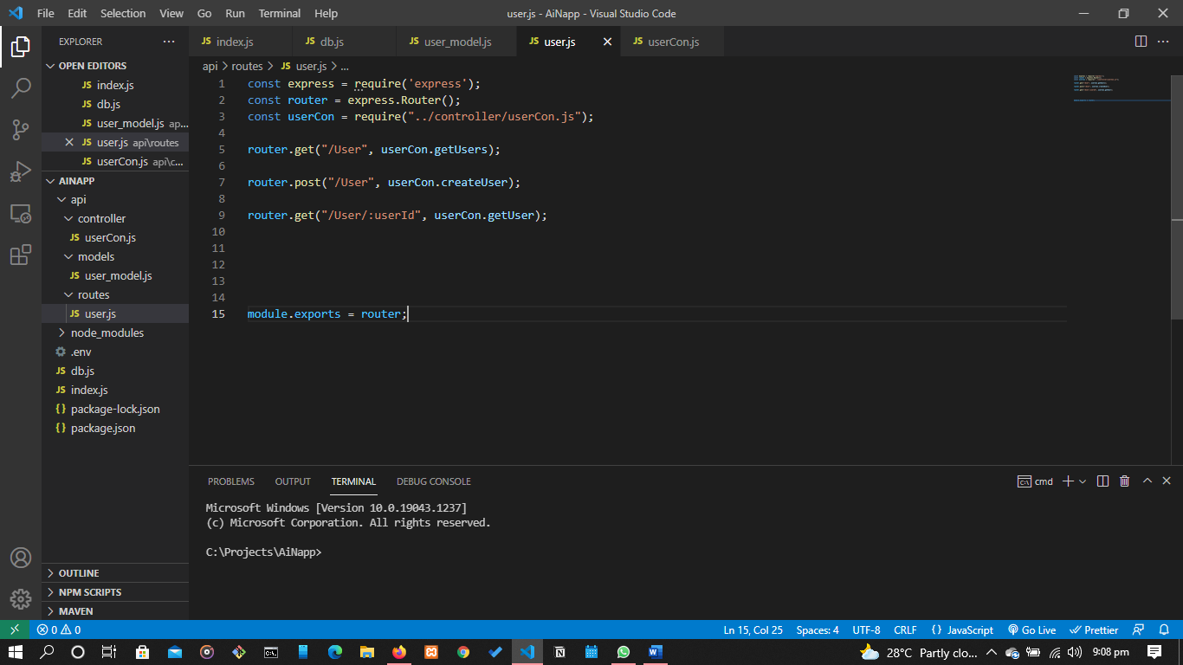

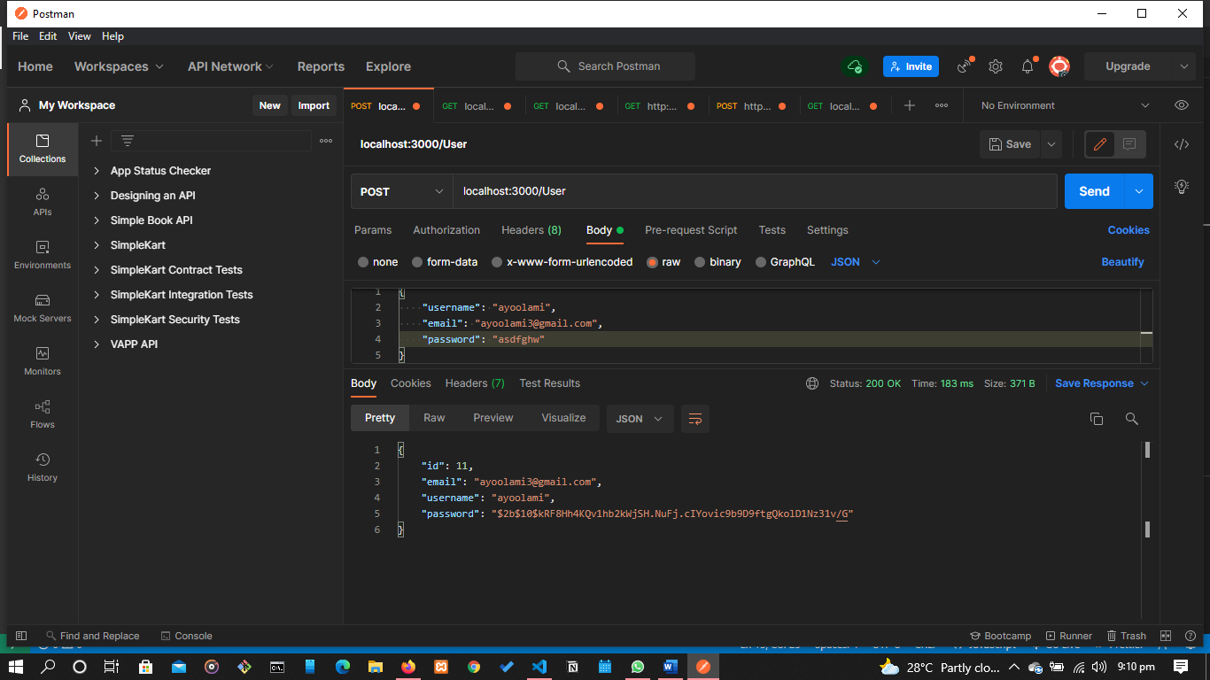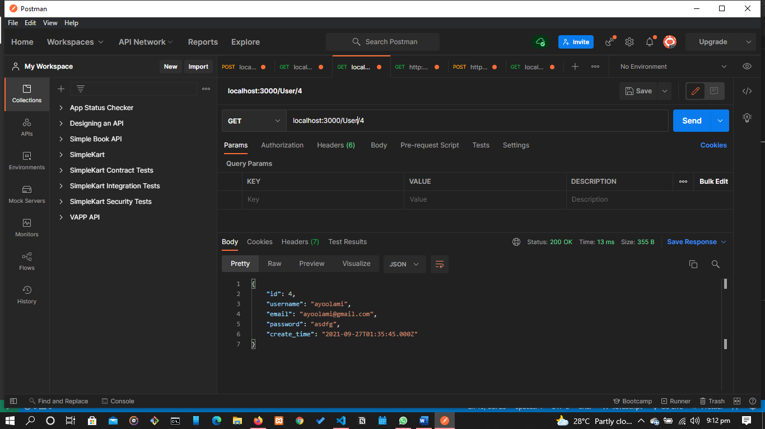

We are yet to get the documentation of the API for EXPA. So, we don’t know the endpoints available.

This month:

1. Other modules will be mapped out and defined
2. Database design will be worked on
3. API’s for other modules will be made